**Practice Newsletter February 2024**

1. **Community project**

**Hawthorns Medical Centre**

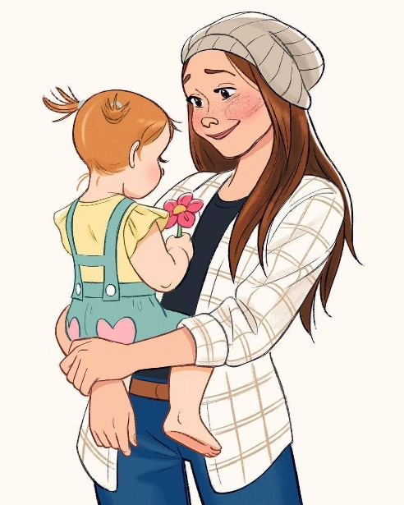

**Mum and baby Yoga and Pampering event.**

**Friday 26th April 2024 10:00am -12:00pm**

At Brasshouse Community Centre

Brasshouse Lane, Smethwick B66 1BA

Can drop in anytime to join the event and get pampered!

Refreshments will also be available too!

1. **Other free activities available at Brass house Community Centre.**

nsdt Community service is also providing some of the following activities for local population. Please make the most.

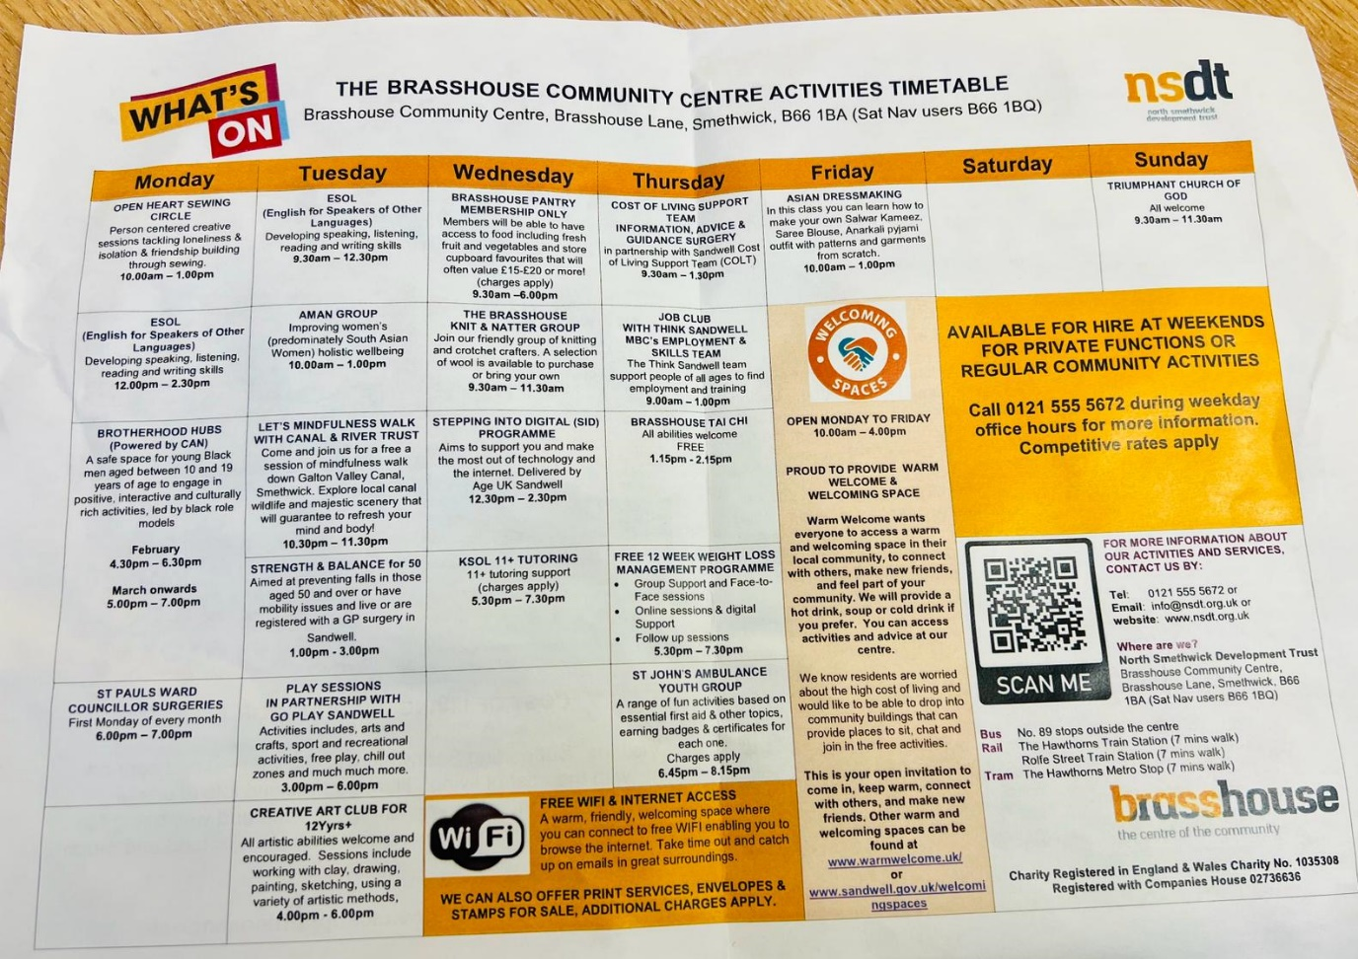

1. **Practice Website has been updated.**