HAWTHORNS MEDICAL CENTRE

TELEPHONE AUDIT:

Written by: Dr S Tillu
August 2017
Background:

From the patient survey carried out in; following response was noted in response to the question “how satisfied are you that you can get through the surgery telephone?”

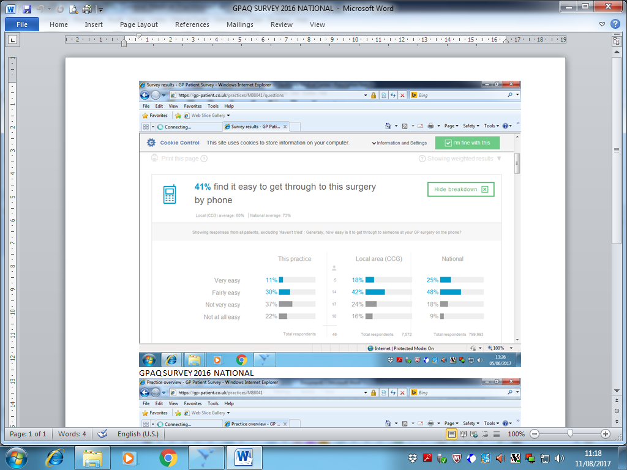

As per GPAQ survey results 2016; 41% patients found easy to get through to this surgery by phone.

On further breakdown of the results; 30% thought it was fairly easy and 11% thought it was very easy to get through to this surgery by phone.

However 37% of the survey respondents thought it is not very easy to get through and 22% respondents thought it is not at all easy to get through to the surgery by phone.

The results appear to be comparable to the local area but are below the national average; as only 27% respondents nationally thought it is difficult to get through by phone compared to 59% of the practice.

As the result of not getting though the surgery on the phone; patients end up attending walk in centres and A and E departments. The indirect result of this is more patients also are admitted as non-elective admissions. Due to the increasing financial pressure on NHS funding it is more important to make savings by reducing inappropriate A and E attendances and urgent admissions in the hospital. One way of improving this is by improving access in primary care by improving telephone access.

The practice as the result, decided to evaluate the patients experience regarding “telephoning the surgery”.

The practice has already taken steps to improve patients’ experience of telephoning the surgery. These are:

- One designated reception staff to answer the telephone and a separate receptionist to manage patients walking in the surgery.
- Restrict the outgoing calls from the surgery’s appointment line during the surgery opening time and instead use the surgery mobile whenever possible.
- Designated time for patients to telephone for results and referral queries after 10 am to free up the line for the appointments.

Aims and Objectives:

- To objectively look at and analyse the patients’ experience of answering telephone by the staff
- To improve the patients’ experience in terms of having to wait for the call to be answered.
- To avoid the phone being engaged for the patients; look at the duration of the calls and alternative options to shorten the duration of the call, so that the line will remain less busy for the patients.

Procedure:

This audit was carried out during the week from 15th June to 27th July 2017. A template was prepared stating the date and time of the call, time taken to answer the call (8 rings = 1 minute) the duration of the call, the particular staff that was dealing with the call and the reason for the call.

A record was made by one independent observer (Anitha Biju the HCA). The total of 110 calls was recorded at different times of the day and on different days. Precautions were also taken to include all four reception staff namely SA, AB, RB and SB.

The duration of the call was measured by using the stop watch with the second hand.

The number of rings heard before answering the call was also measured.

Observation:

Following observations were made.
All the telephone calls were answered between 1 to 3 rings.
Only two calls were answered after 3 rings and all other calls were answered after 1 to 2 rings.
The average number of rings heard before answering the call was 1.25 rings. This equated to 8 secs.
This was an excellent finding.

One ring | Two rings | Three rings | Four rings | Five rings.
74 | 34 | 2 | 0 | 0

Majority of the calls; 74 out of 110 calls were answered after 1 ring.

34 calls out of 110 calls were answered after 2 rings.

Only 2 calls were answered after 3 rings.

The duration of the call ranged from 3 seconds minimum to 2 minutes maximum.

The average duration of the call was 46.4 seconds.

The majority of telephone calls were to book appointment with the clinician, few were to cancel the appointments, few were to confirm the appointment time.

Some telephone calls were regarding medication query, two were vaccination and some were for Xray results and blood results. Only few calls were asking about new patient registration.

Majority of the telephone calls were from patient or their family members. Only three were from chemist asking about meds query, one from 2 weeks fast track referral, one from social services, one asking for practice manager.

Action plan:

- Answer all calls within 3 rings. As per the audit, the average no of rings heard before answering the call were 1.25 rings. This was excellent finding and all staff were congratulated for their good work. However this may not be the case every time and AH (reception manager) and HG (practice manager) would keep close eye on this.

- Always ask if it is “very urgent?” This will happen when someone from outside such as a consultant or community nursing etc telephones to speak to GP. Explain them the surgery policy that all telephone calls are answered at the end of the morning surgery unless it is very urgent and book in the telephone slots with contact no and the name of the patient.
If a GP has a free slot one may wish to send the little message.

- If the telephone call is about the results, referral queries or registration, they can be advised to look up the practice website for further information. Patients can see their results online or alternatively they can be booked with the clinician in the telephone appointment slots
Registration information is given on the website including practice area map, the process of registration and access to registration form.

- Minimise the time taken to book an appointment. Extra time may be taken by the patients when the patient is requesting to see specific clinician at specific time. This cannot be specifically encouraged unless there is very specific reason for this.

- More use of online prescription requests and not on telephone or walking in; as it will free up the telephone line for the appointments and patients can request prescriptions 24 hours a day as per their convenience.

- Always use the surgery mobile for outgoing landline and mobile numbers during the time when patients are likely to ring for their appointments. Alternatively the fax line can also be used to call out.

- Use of “text reminders” for the appointments. This will hopefully reduce DNAs and telephone calls asking to confirm the time of the appointment. This also will free up some reception time. HG to liaise with the ICT to set up the service. Reception staff must make sure the contact numbers on patient’s records and up-to-date and verify them when checked.

Re-audit

Re audit is planned at a later date in about 6 months’ time.

